Lab No.: Lab-3
Lab Aim and Objective: To implement Find-S and Candidate Elimination Algorithms on the Enjoy Sports dataset and compare the generated hypotheses.
Dataset or resources used: Enjoy Sports dataset (enjoysport.csv), Python, Jupyter Notebook, Pandas, Numpy.
Date of Performance: 09 August 2026

1. Theory based on the lab objectives
Concept learning is a core task in machine learning where the goal is to infer a boolean-valued function from training examples of its input and output. A hypothesis is a representation of this learned function. Two foundational algorithms for concept learning are Find-S and Candidate Elimination.
1. Find-S Algorithm: This algorithm finds the most specific hypothesis that fits all positive examples. It starts with the most specific hypothesis in the hypothesis space (all constraints) and gradually generalizes it each time it encounters a positive example that it fails to cover. It ignores all negative examples.
- Pros: Simple and easy to implement.
- Cons: Cannot handle inconsistent data (noise) and ignores negative examples, meaning it might not find the single best target concept if multiple exist.
2. Candidate Elimination Algorithm: This algorithm is more robust as it utilizes both positive and negative examples to compute the version space. It maintains two boundaries: a most specific boundary (S) and a most general boundary (G). As it processes training examples, it generalizes S for positive examples and specializes G for negative examples until both boundaries converge.
- Pros: Outputs a version space containing all consistent hypotheses, handles negative examples, and can detect inconsistent data if the version space becomes empty.

2. Written code uploaded to GitHub
The written code for this practical is uploaded and available at the following GitHub URL:
https://github.com/NodeNexus/MachineLearningProjects

3. Procedures and materials used
Materials Used:
- Hardware: Standard PC/Laptop
- Software: Windows OS, Python 3, Jupyter Notebook
- Libraries: Pandas (Data handling), Numpy (Numerical operations).
Procedures:
1. Created and loaded the Enjoy Sports dataset (comprising features like Sky, AirTemp, Humidity, Wind, Water, Forecast and target variable EnjoySport).
2. Implemented the Find-S Algorithm by initializing a specific hypothesis with the first positive example.
3. Iterated through the dataset, generalizing the specific hypothesis only when a positive example contradicted it, ignoring negative examples entirely.
4. Printed the step-by-step hypothesis updates and the final most specific hypothesis.
5. Implemented the Candidate Elimination Algorithm by initializing the specific boundary (S) with the first positive instance and the general boundary (G) with completely general constraints ('?').
6. Processed positive instances by generalizing S, and processed negative instances by specializing G to eliminate inconsistencies.
7. Printed the boundaries at each step and derived the final version space.
8. Compared the outputs of both algorithms.

4. Output screenshots with proper descriptions
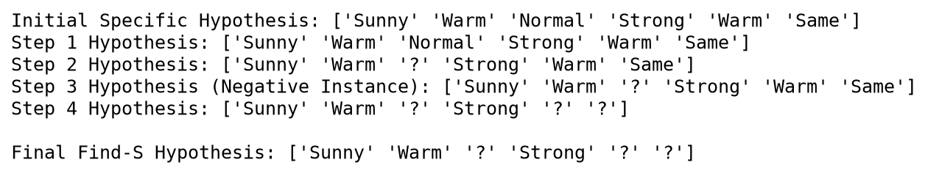
This output screenshot displays the step-by-step execution of the Find-S algorithm. It starts with the first positive instance as the initial specific hypothesis. As it encounters subsequent positive instances (Step 2 and 4), it replaces specific attribute values with generic wildcards ('?') if they differ. Negative instances (Step 3) are completely ignored. The final hypothesis represents the most specific conditions required to enjoy sports.

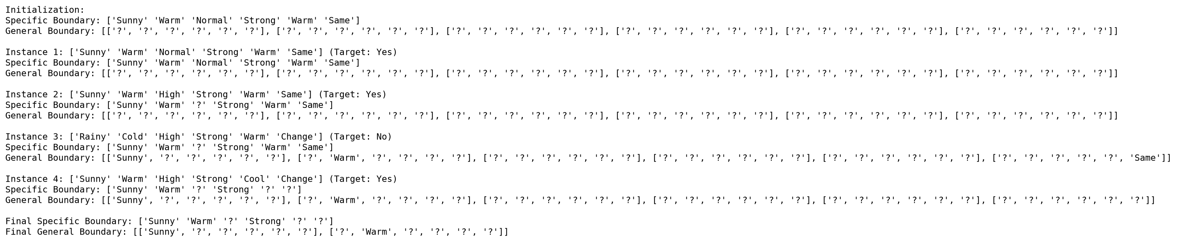
This screenshot illustrates the execution of the Candidate Elimination algorithm, showing the evolution of the Specific (S) and General (G) boundaries. Positive instances cause the S boundary to generalize, similar to Find-S. Crucially, when a negative instance is encountered (Instance 3), the G boundary specializes to exclude it while still covering the positive instances. The final output yields a version space bounded by S and G.

5. Viva Questions
Q1. What is a Version Space in machine learning?
Ans: The Version Space is the subset of all possible hypotheses from the hypothesis space that are consistent with all the observed training examples (both positive and negative). It is typically represented by its most specific (S) and most general (G) boundaries.
Q2. What is the main limitation of the Find-S algorithm?
Ans: The main limitation of Find-S is that it ignores negative examples. Consequently, it has no way to determine whether it has found the only consistent hypothesis or if there are others. Furthermore, it assumes the training data contains no errors or noise, as inconsistent data can cause it to fail silently.
Q3. How does Candidate Elimination handle negative examples?
Ans: When the Candidate Elimination algorithm encounters a negative example, it specializes the General boundary (G). It creates new hypotheses in G that are less general, ensuring they correctly classify the negative example as negative while remaining consistent with all previously seen positive examples.
Q4. What does the '?' symbol represent in these concept learning algorithms?
Ans: The '?' symbol represents a completely general constraint for a specific attribute. It means that any value for that attribute is acceptable for the hypothesis to hold true. It is introduced when a hypothesis is generalized to cover varying values of an attribute across positive examples.
Q5. Can the Candidate Elimination algorithm detect noisy data? If so, how?
Ans: Yes, Candidate Elimination can detect noisy or inconsistent data. If the training data contains contradictory examples (e.g., two identical instances with different target labels), the Specific and General boundaries will eventually cross or become empty, indicating that the Version Space is empty and no consistent hypothesis exists.

